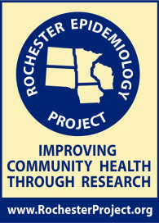
Rochester Epidemiology Project
Community Advisory Board
July 16, 2013 – 5:30pm
Olmsted Medical Center – NW Clinic
Conference Room 2 (lower level)

Meeting #4
Agenda

Tuesday, July 16, 2013
Time | Event | Speaker
5:30 p.m. – 6:00 p.m. | Dinner and discussion  - Review the current REP display materials | Chris Burdick
6:00 p.m. – 6:10 p.m. | Co-chair updates | Dr. Barbara Yawn  Chris Burdick
6:10 p.m. – 6:45 p.m. | Scientific update  Grant update  - Patient Centered Outcomes Research Institute (PCORI) | Dr. Jenny St. Sauver  Dr. Barbara Yawn
6:45 p.m. – 7:45 p.m. | Work Teams Discussion  - Olmsted County Fair  - Rochester Women’s Expo  - Booth display and materials  - Facebook | Dr. Barbara Yawn  Chris Burdick  Dr. Barbara Koenig
7:45 p.m. – 8:00 p.m. | Meeting Wrap Up | Dr. Barbara Yawn  Chris Burdick

